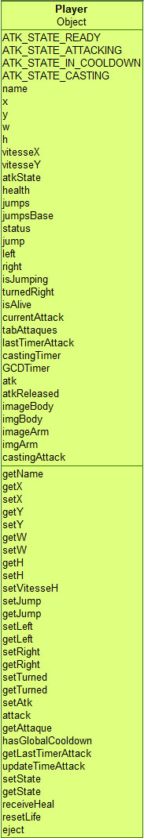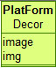D:\Java\Workspace\SuperStreetMelee\images\ground.jpgD:\Java\Workspace\SuperStreetMelee\images\levels.jpg